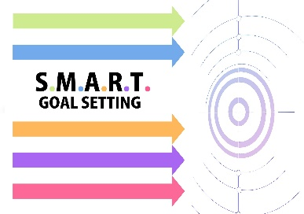

Specific: What is your goal?

Measured: How will you track your progress?

Attainable: How can it be accomplished?

Relevant: How is it relevant to your career goals and the mentoring relationship?

Time bound: When will it be accomplished?

